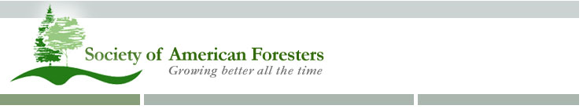

Tom Westergreen

4800 South Pass Road

Sumas, WA 98295

Dear

The Washington State Society of American Foresters (a non-profit organization) is proud to announce that it will hold its annual meeting on May 12-14, 2016, at Maple Hall in La Conner, Washington. The historic waterfront village of La Conner is in Skagit County on the Swinomish Channel, close by the internationally known tulip and daffodil flower fields on the Skagit Flats. The theme of this year’s conference is “A Walk Through The Woods.”

I invite you to be a part of this conference with a sponsorship. Sponsor logo displays will be set up on the stage behind the speaker’s podium and along the perimeter of the main conference room, giving you excellent exposure to all convention participants. Sponsorships are available at the following financial support levels:

Sponsor Name: ______________________________________________

Address: ___________________________________________________

City, State / Province and Zip: ___________________________________

Phone: _____________________________________________________

Email: ______________________________________________________

**Platinum ($1,000)**

**Gold ($500)**

**Silver ($250)**

**Bronze ($100)**

**Student Sponsorships ($75)**

*(Checks payable to North Puget Sound SAF)*

We are also looking for sponsors of the Wednesday evening icebreaker event. Hors d’oeuvres and beverages will be served.

As has been done in the past, this year’s annual meeting will feature a raffle to support the WSSAF Foundation. This Foundation was created to provide scholarships for forestry students and support other forestry education projects. If you also wish to donate an item for the raffle (e.g. clothing, product, etc.) it would be greatly appreciated.

Please complete this sponsorship box above by **Monday, May 2, 2016,** ande-mail (preferred method) mail or fax it to me. Please also email me the company logo you would like used for recognition purposes.

A schedule of our 2016 Washington State Society of American Foresters meeting is attached. Additional information about the meeting can be found at www.forestry.org/washington/2016Meeting/. Please let me know if you have any questions.

Sincerely,

Tom Westergreen

Tom Westergreen

WSSAF Exhibitor Chair

360-961-0312 (cell); 360-966-3605 (home); 360-966-9996 (fax)

[tomwestergreen@hotmail.com](mailto:tomwestergreen@hotmail.com)

ATTENDEE PROFILE: The Washington State Society of American Forester’s Annual Meeting will attract approximately 120 foresters and natural resource managers from across Washington State. They include private industry foresters, state agency foresters, forest consultants, federal agency foresters and small tree farm managers. Most have job responsibilities that involve growing trees, harvesting trees, and managing forestlands for a multitude of other benefits. We have also extended an invitation to Canadian Institute of Forestry members.